There are many articles written on this subject by various experts but one thing that I felt was missing was aligning the SAP concept with the real business scenarios or case study. My intent for writing this article is to try and explain the SAP concepts of product costing with the relevant business case.

This article will cover the following process

1. Standard costing process
2. Actual transaction overview with accounting entries for the process

Please note I am intending to cover the business process and align the same with SAP concepts. This article is not intended to provide E2E/detailed implementation process or step by step configuration of the scenario.

Generally, the following type of materials are costed in any business environment.

1. Raw Material
2. Semi-Finished Goods
3. Finished goods
4. Packing materials

The concept of costings in SAP applies for different products in different ways based on the configuration and master data set for materials.

To understand the entire concept, let’s take a business example.

We are a manufacturing entity which manufactures “FG- A” from the factory. To produce “FG-A”, we need raw materials “RM-B”, “RM-C” and RM-D” in the ratio of 2:3:5 for 1 unit of “FG-A”. Additionally, 1 unit of the packing material is required for packing the FG-A. All the raw materials are procured from outside.

|  |  |
| --- | --- |
| Materials | Opening Stock Available |
| RM-B | 100 units @ 3/unit |
| RM-C | 120 units @ 8/unit |
| RM-D | 130 units @7/unit |
| PM-G (Packing Material-E) | 150 units @ 3/unit |

During the start of the period, the sales team has estimated the market demand for the next quarter for “FG-A” to be 8000 units. Based on that, the procurement team has provided the following data.

Apart from this, the production team has informed us with the following estimates for manufacturing 1 unit of “FG-A”

|  |  |  |  |
| --- | --- | --- | --- |
| Cost Center | Activity | Number of hours/required per unit | Price per hour |
| CC1 | Molding -Labor hours | 3 | 12 |
| CC1 | Molding Machine hours | 4 | 10 |
| CC2 | Wielding- Labor hours | 4 | 13 |
| CC2 | Wielding – Machine Hours | 3 | 15 |
| CC3 | Packing- Machine | 1 | 1.5 |

Further Overheads is estimated to be 10% of the total material cost of the product.

Based on this information, we are required to calculate the standard cost estimate for FG-A for the coming quarter.

Now before we move to SAP, let’s estimate the price of the Finished goods for theoretical and comparison purposes.

|  |  |  |  |
| --- | --- | --- | --- |
| **Particulars** | **Qty** | **Price** | **Total** |
| **Material** |  |  |  |
| -RM-B | 2 | 3 | 6 |
| -RM-C | 3 | 8 | 24 |
| -RM-D | 5 | 7 | 35 |
| -PM-G | 1 | 3 | 3 |
|  |  |  |  |
| **Labor** |  |  |  |
| -Molding | 3 | 12 | 36 |
| -Wielding | 4 | 13 | 52 |
|  |  |  |  |
| **Machine** |  |  |  |
| -Packing | 1 | 1.5 | 1.5 |
| -Molding | 4 | 10 | 40 |
| -Wielding | 3 | 15 | 45 |
|  |  |  |  |
| **Overheads** |  |  | 6.8 |
| -10% of material cost |  |  |  |
|  |  |  |  |
| **The total estimated price of FG-A** | | | **249.3** |

Now we know the theoretical standard price of the product, let’s align it with SAP concepts.

From SAP’s perspective, when we talk about product costing concept, it is basically divided into four parts i.e.

1. Product Cost Planning
2. Cost Object Controlling
3. Actual Costing/Material Ledger
4. Information System

Since Product costing is a part of the controlling module, it helps in calculating the cost of manufactured material from the information supplied by overhead cost controlling and transmits the information to COPA to calculate margin analysis. Please note that the prime purpose of using this is to calculate and estimate the internal cost of manufacturing the material in-house.

All the customizing required for configuring the product costing is done in Product cost controlling section, whereas cost object controlling deals with the cost incurred by a company to units within the company, such as products, product groups or orders.

**Planned/Standard/Estimated Cost:**

* In SAP, we have two approaches to calculating planned/estimated cost of the material.
  + Material Cost estimate with Quantity Structure
  + Material Cost Estimate without Quantity Structure. (This will be covered in next blog)

**Material cost estimate with Quantity Structure**

Let’s align the different component of manufacturing with the different master data/configuration in SAP.

1. Raw Materials – This information is stored in BOM in SAP. BOM i.e. Bill of Material contains the list of raw material or packing goods which will be used to manufacture the finished goods. In our example, we will be using RM-B, C and D for manufacturing FG-A in the ratio of 2:3:5 and 1 packing material. This information is captured in BOM. From the finance perspective, the cost of raw material will be derived in the following ways.
   * Quantity information – From BOM
   * Price information- From the material master

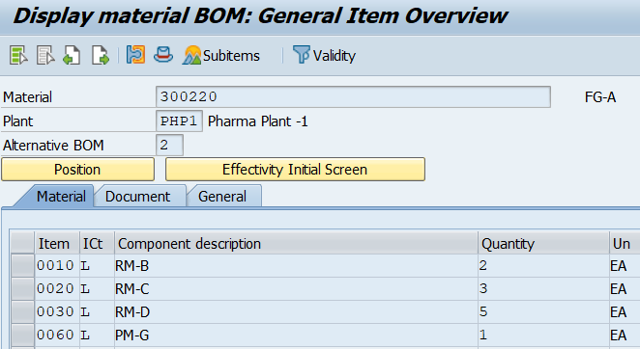

Please note the following specific points for Raw Material Configuration which is relevant to costing.

* Procurement Type- Since our raw materials will be externally acquired, we have set the procurement type as “External Procured”.
* Price strategy- R.Ms will be evaluated as moving average price rather than the standard price, whereas Finished good will be evaluated at the standard price.

1. Labor/Machine hours. This information is stored in Routing. Routing covers the quantum of activities that will be performed to manufacture the material. In our case it is molding, wielding and packing which are done by machine or labor.

From the SAP perspective, this information will be entered in two places.

1. Activity type planning for cost centers- This will capture information of activity type and its estimated price.
2. Routing – This master data will capture the activity type and number of hours required to manufacture finished goods.

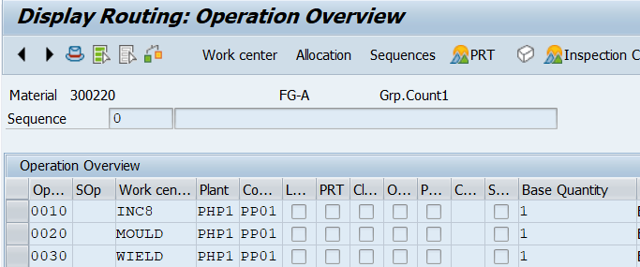

Now, the question of aligning this information arises because the first information is captured with respect to cost center while the latter one is captured with respect to Work center.

This is where the beauty of SAP comes. If you see the below the screenshot of Work center master data, you can observe that each work center is assigned to a cost center i.e. we can assign work center to one cost center only whereas we can have many work centers assigned to a single cost center. In this way, the system will align both the information and provide the cost.

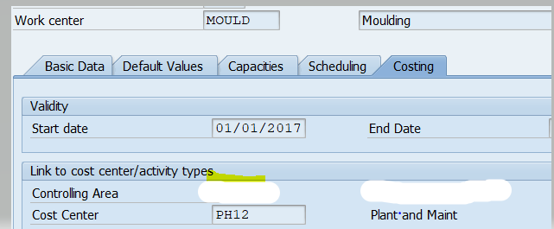

1. Overheads

As can be seen from our example, we also have some overheads that need to be allocated to the estimated price of the finished goods.

In SAP, we use the functionality of the costing sheet for assigning the overheads. The costing sheet can assign all the indirect cost that is estimated to be incurred on the final product.

We have two methods available for allocating the overheads. These are available for planned as well as for actual overheads allocation.

* Percentage allocation Method
* Quantity allocation method

Our case falls under the percentage allocation method, so we have defined the same in configuration.

**Cost Component Structure**

We have covered each of the components but as far as SAP goes, this all needs to be aligned to an appropriate structure to get the desired output. Structuring of this information is done with the help of costing component structure.

Now let’s say we are preparing the cost sheet as per management accounting, the cost sheet will contain the header details such as Direct Material, Direct Labor, Machine Hours, Factory O/Hs, Admin O/Hs, Selling and distribution Overheads, etc.

These header details will then be filled with each line item details e.g. Direct Material will contain the different types of raw materials.

In SAP, this functionality is called Cost Component Structure. You give one name to a structure i.e. Y1 (in our case). Then you would define the header details like materials, labor, etc. Then for each of the details, you will define the line items and assign the cost elements. There are various other details for this but for our concept building, I will restrict the explanation only to this.

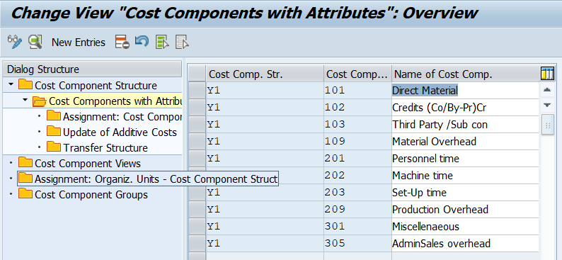

Now since everything is done, let’s run the cost estimate using CK40N and check the estimated price of the finished goods.

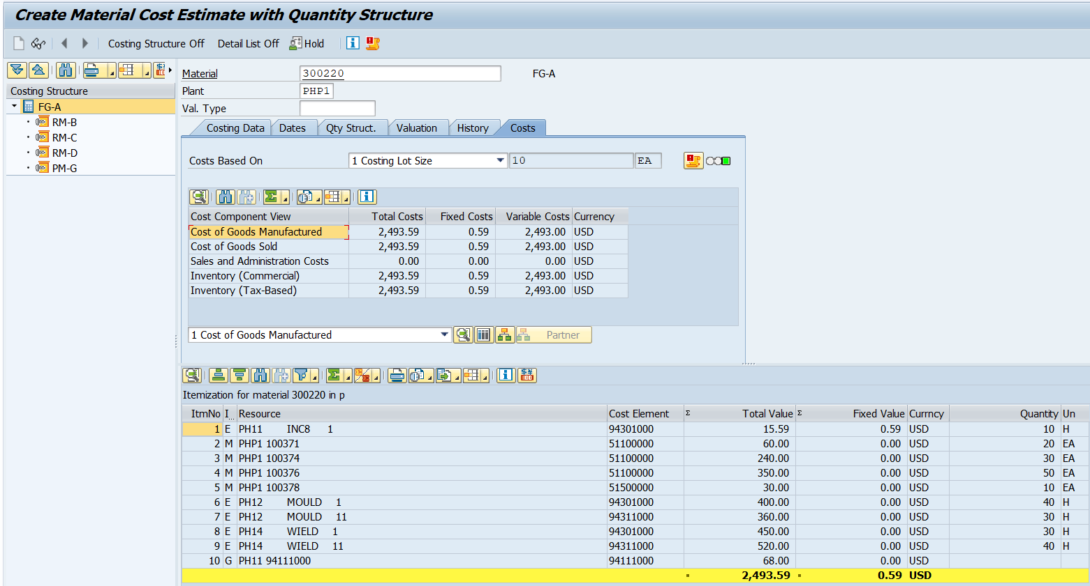

Note- Our costing lot size is of 10, so per unit cost is 249.3.

Let’s save the standard cost and mark &release it using CK24 for updating our material master.  Once done, our material master will be updated.

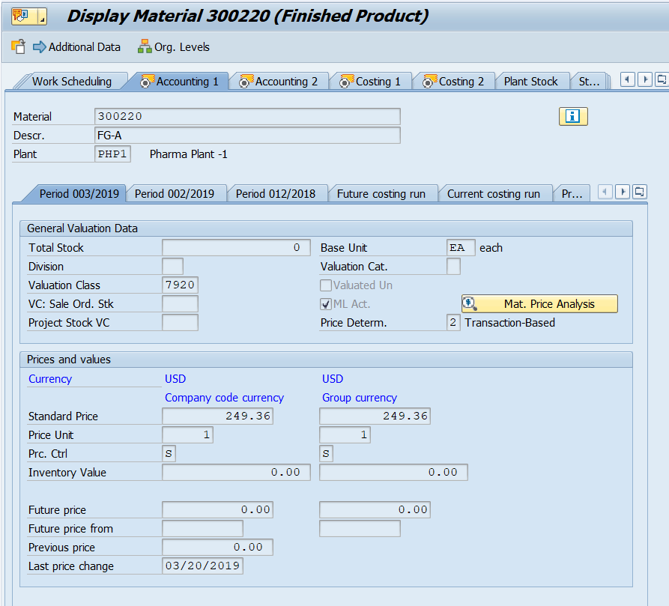

Now, we have the standard cost, let’s perform some actual transactions for the period.

I am sharing the list of the process w.r.t accounting entries.

1.Create a Production Order

– No accounting/controlling entry at that time.

2. Create a PO for Raw Materials

* No accounting /controlling entry

3. Receipt of Raw Material to warehouse

Raw Material Inventory Debit

GR/IR clearing Credit

4.Issue of RM to Production Order Created earlier

Consumption of Raw Material Debit

Raw Material Inventory credit

5.Confirmation of Routing activities

No FI document. Only CO document

Cost element for Routing activity type i.e Machine, labor, etc. Debited with the Production order

Cost element for Routing activity type i.e Machine, labor, etc. credit with cost center

6. Booking actual overheads.

No FI document. Only CO document

Cost element for Overheads Debited with the Production order

Cost element for Overheads credited with cost center

7. Finished good receipt from Production order to Warehouse.

FG inventory Debit

GR/IR for FG inventory

8. Calculating and saving Variance.

No Accounting entry during this time

9. Settlement of Production Order

* If the variance is positive

Main Variance Account Debit

GR/IR for FG credit.

Splitting of other variance into different Account like Material, Labor, etc. Debit

Main Variance Account Credit

* If Variance is negative,

GR/IR for FG Debit.

Main Variance Account Credit

Main Variance Account Debit

Splitting of other variance into different Account like Material, Labor, etc. Credit

With this section, I have provided the working of the material costing with quantity structure. I intend to cover the material cost estimate without quantity structure in the next blog. Please provide your valuable comments and help me improve.